I fixed two problems in the program. First is “Soft 17” and other is “equal rule”.

“equal rule”:

For make it easy to add other variants without change a lot. I use interface to implement this function. First I create a “interface” call “WinRule”. “WinRule” has a method “IsWin”. This method has two parameters. Player and Dealer.

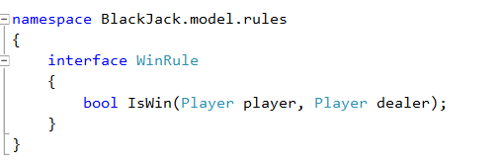

Than，I create a DealerWinRule class and PlayerWinRule class, All this class extend from WinRule interface. It mean that next time if we want to create a new rule, we only need to create a new class and extend from WinRule interface.

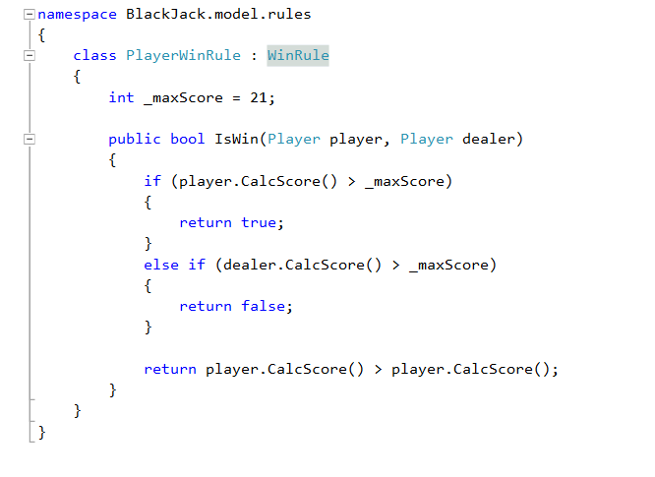

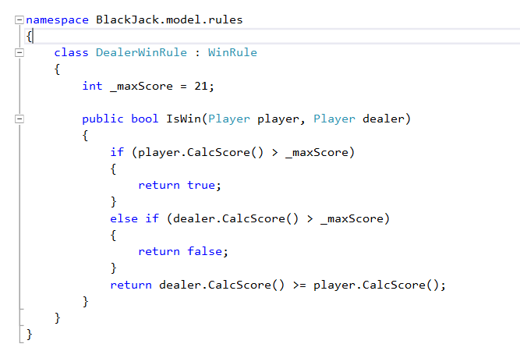

In first time, I make a wrong design, I implement the requirement in Dealer class. But this design has a big problem. It is hard to add or change a new rule. And now I change my design.

“Soft 17”:

The logic of “soft 17” is similar the “equal rule”. The old version is I implement the “soft 17” in Dealer class. Now, I create a “IHitrategy” interface. And I create a class call “Soft17HitStrategy”. This class is extends from “IHitrategy” interface. It is mean that next time if I want to add a new strategy. I just need to create a new class and extends it from “IHitrategy”. And implement new strategy in the new class. Now，I don’t need to change anything in dealer class and add a new rule or strategy but use interface to implement it.

